The Magic Finger (Written by Ronald Dahl, Illustrated by Quentin Blake)
Class: Number: Name:
Part A. Grammar & Context
In the novel, identify sentence patterns you learned in this semester. Write down at least two examples from the book, and include the page number(s) for each example.
使役動詞 | S. + make/let/have + O. + V.
Sentences written in the book
1. Page ____: __________________________________________________________________
__________________________________________________________________
2. Page ____: __________________________________________________________________
__________________________________________________________________

名詞子句 | S. + V. + that/wh- S. + V.
Sentences written in the book
1. Page ____: __________________________________________________________________
__________________________________________________________________
2. Page ____: __________________________________________________________________
__________________________________________________________________

感官動詞 | S. + smell/feel/taste/look/sound + like N / Adj.
Sentences in the book
1. Page ____: __________________________________________________________________
__________________________________________________________________
2. Page ____: __________________________________________________________________
__________________________________________________________________

句中分詞構句 | S. + V.…., Ving/P.P…
Sentences in the book
1. Page ____: __________________________________________________________________
__________________________________________________________________
2. Page ____: __________________________________________________________________
__________________________________________________________________
Part B. Vocabulary & Search
From the puzzle, identify 16 vocabulary words used in the book. Then, write down their meanings in both English and Chinese, and copy the sentences from the book that use these words. Make sure the meanings match how the words are used in the quoted sentences.
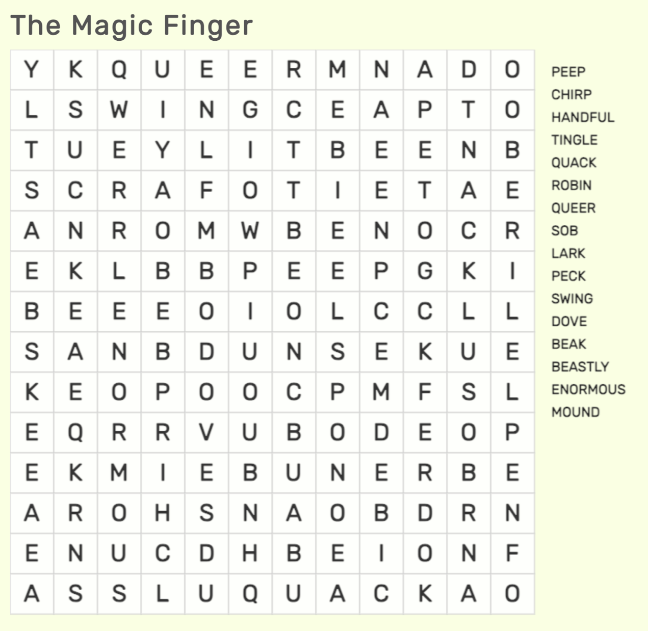

Vocabulary |  |  | Meaning
peep |  |  | (meaning)
(quote the sentence)

chirp/chirrup |  |  | (meaning)
(quote the sentence)

handful |  |  | (meaning)
(quote the sentence)

tingle |  |  | (meaning)
(quote the sentence)

quack |  |  | (meaning)
(quote the sentence)

robin |  |  | (meaning)
(quote the sentence)

queer |  |  | (meaning)
(quote the sentence)

sob |  |  | (meaning)
(quote the sentence)

lark |  |  | (meaning)
(quote the sentence)

peck |  | (meaning)
(quote the sentence)

swing |  | (meaning)
(quote the sentence)

dove |  | (meaning)
(quote the sentence)

beak |  | (meaning)
(quote the sentence)

beastly |  | (meaning)
(quote the sentence)

enormous |  | (meaning)
(quote the sentence)

mound | (meaning)
(quote the sentence)

Part C. Short Summary & Critical Thinking
Answer the questions based on the plot and your understanding of the novel.
1. Describe how the Magic Finger works.

2. How does the Gregg family’s life change while they have wings?

3. What important message does Roald Dahl want readers to learn?

4. The Greggs change their last name to Egg at the end. Why do you think the author chose this name? What does it symbolize?

5. If you had the Magic Finger, what rules would you make for yourself so that you wouldn’t misuse it?

